EV market segmentation

-Daksh Agiwal

What is the future scope of Electric Vehicles in India?

Electric car manufacturing is getting increasingly popular, and its market share is likely to grow significantly. By 2022, India's GDP is predicted to increase by a staggering 25%.

The best aspect is that, in addition to decreasing pollution, EVs can reduce oil imports by $60 billion by 2030. Currently, imports account for 82 per cent of India's oil requirement. As a result, it is clear how helpful it will be for the Indian economy if the import cost is decreased. Electric automobiles are being developed primarily because they do not emit any pollution when driving. An electric vehicle is propelled by a battery-powered electric motor. Aside from the fact that more cities are implementing LEZs, these zones are also growing in size and strictness with time. While estimates ranged from more than 20% to almost 90%, executives in the study predicted that by 2030, 52 per cent of new car sales would be all-electric.

The dataset that I have used –

<https://www.kaggle.com/datasets/ratikkakkar/electric-vehicle-population-data>

Visualizing the dataset

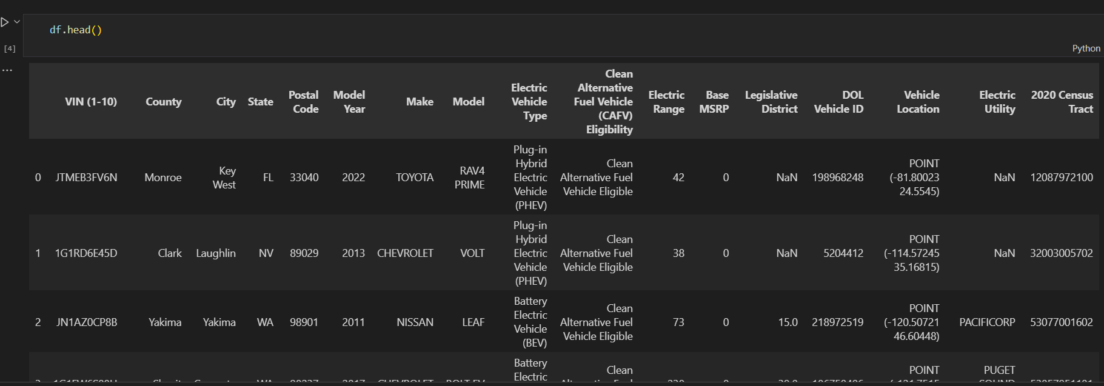

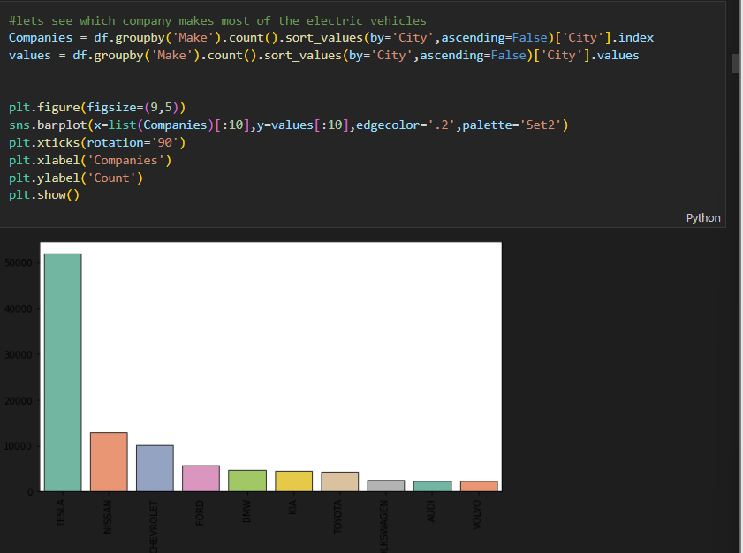Extracting companies which makes most electric vehicles

Top 10 models in use

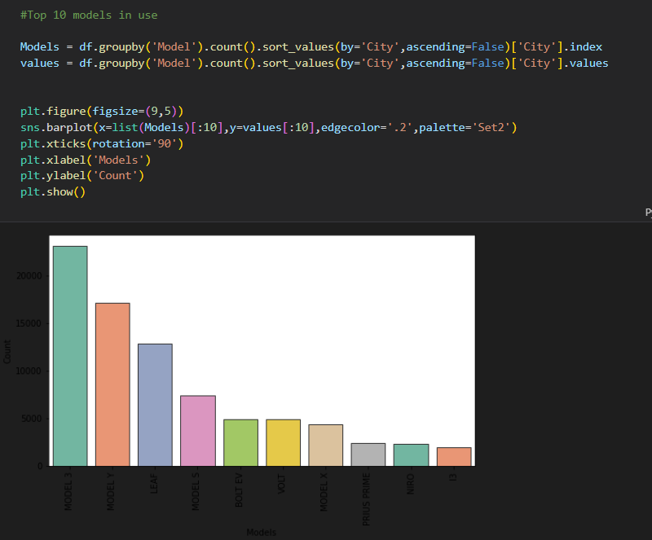

Filtering out top 5 companies as per electric vehicle type

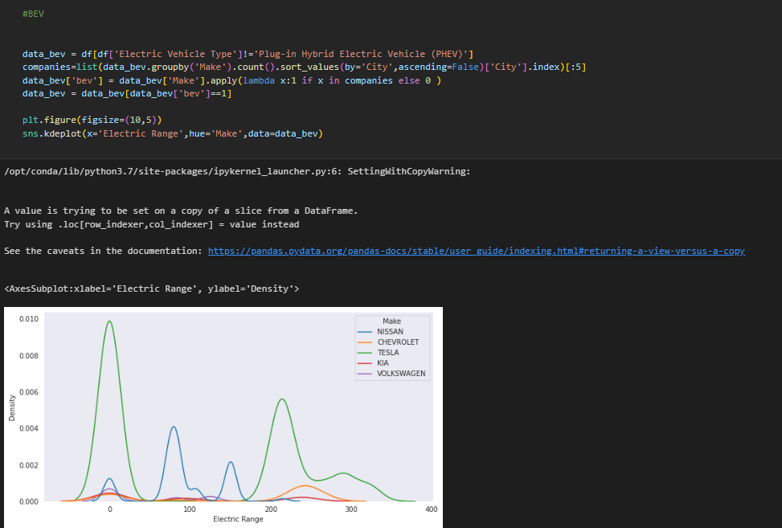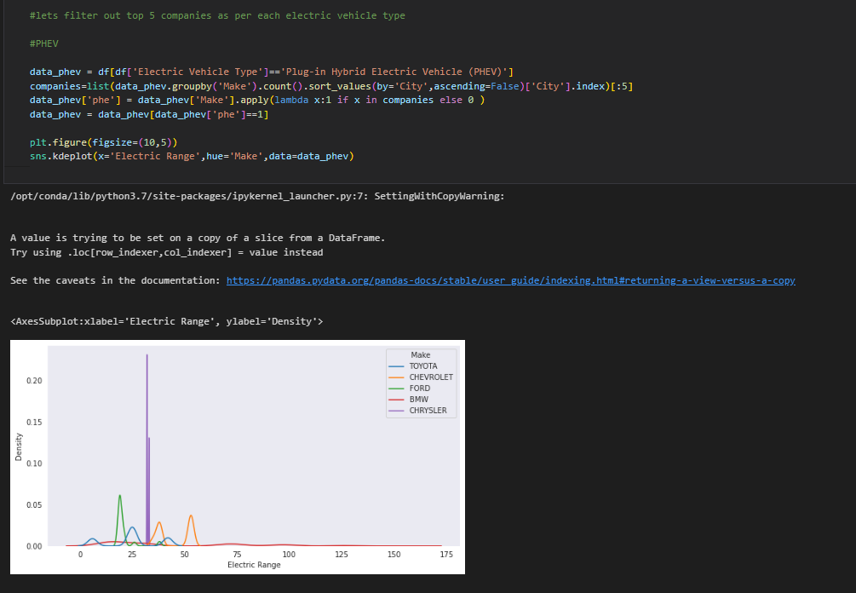

Number of models of company for each year over last 10 yrs

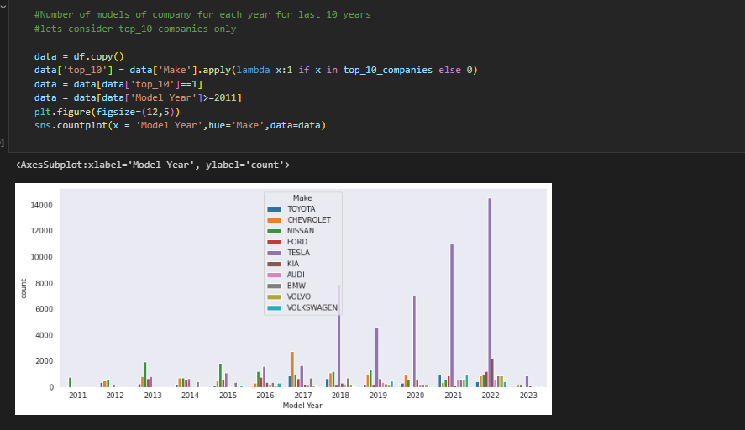

Let us analyse the data for a specific company that is tesla

As per state

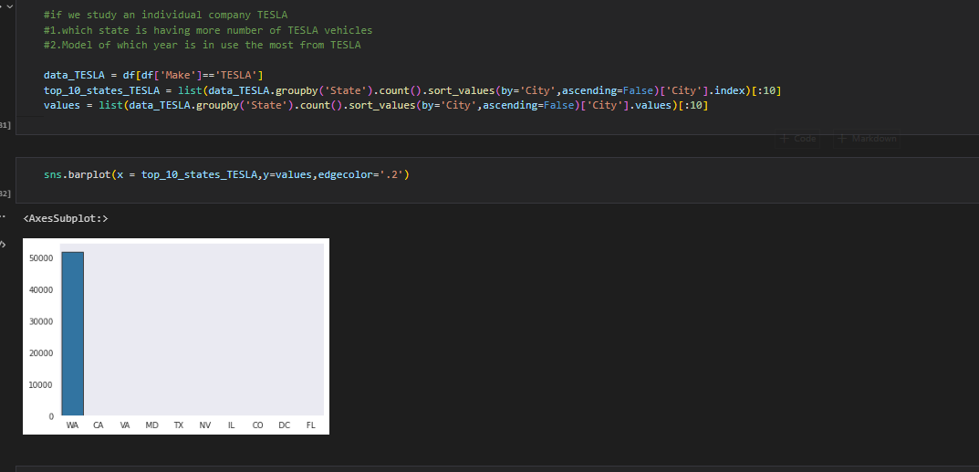

As per longitude and latitude grouping

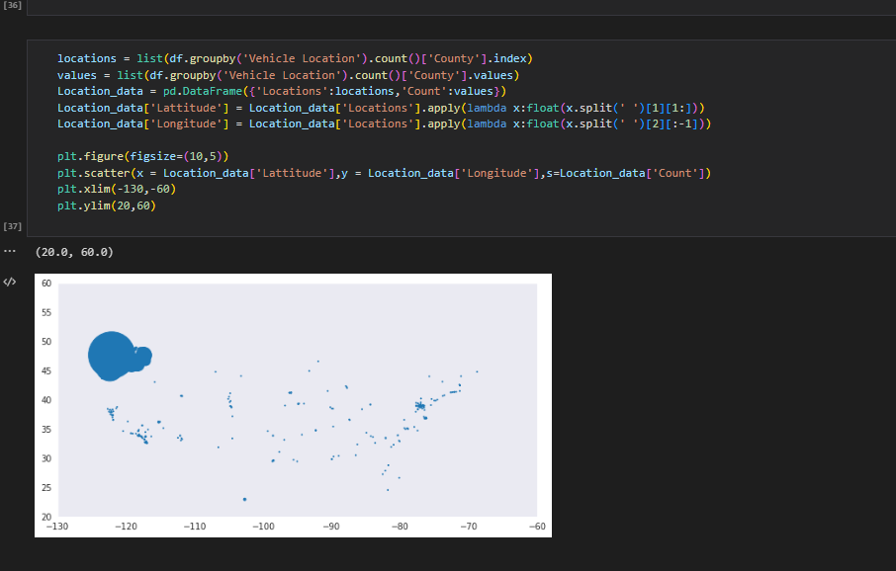

Predicting the number of electric cars based on the year using XG boost algorithm

